ARISTEIDIS TSIRIMIANGOS
CORFU, GREECE
e-mail: aristidis.tsirimiangos@gmail.com

TITLE OF PRESENTATION:
TWO SIMPLE IDEAS FOR MEASURING AREA AND TIME

WHO ARE WE?
My name is Aristeidis Tsirimiangos and I welcome you to the Greek stand.
I represent a group of three high school teachers, teaching every science subjects in our schools, in Corfu, Greece.
In addition we have another occupation: We provide support to all our colleagues concerning the experimental teaching. We cover the whole island, on where we live, by visiting them at school. We regularly arrange meetings and we inform them about the new ideas and thoughts and in general everything that has to do with the experimental teaching.

WHAT DO WE PRESENT HERE?
In this project we present two different experimental constructions that are based on simple ideas.
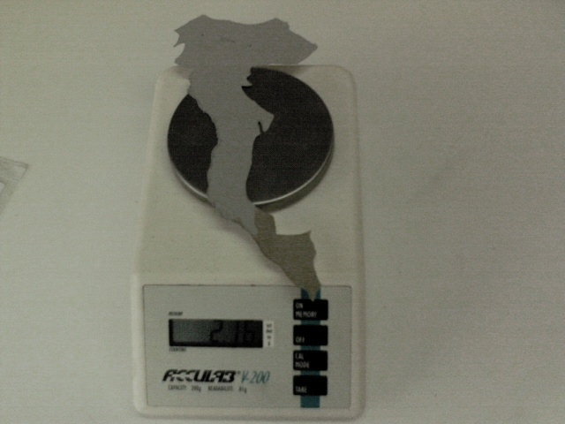
The first is about the measurement of the area of a country or a region with the help of a balance! We turn the measurement of area into the advantage of the proportion between the surface of a piece of paper or plastic (with constant density and thickness) and its mass. Using a map we cut a piece of paper or plastic in specific dimensions, based on the scale of the map. Thus we know the area on which it corresponds (A₁). Afterwards we cut another piece of the same paper or plastic in the shape of the country that we want to measure (A₂).
Finally, we weigh both pieces, one after the other. If M₁ and M₂ are the values of the two masses then we will get the unknown area by the following calculation:
A₂=(M₂/M₁) * A₁

Alternatively we can use a simple balance made of a rule. We equilibrate the two masses by putting them on both sides of the rule. We measure the lengths L₁ and L₂ of the equilibrium and we calculate the unknown area by the following calculation:
A₂=(L₁/L₂) * A₁

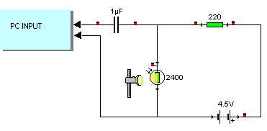
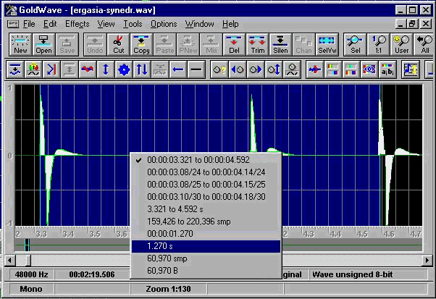
The second construction uses the sound card of a PC as an electronic timer. This can be realised by leading an electric pulse of a self-made lightgate, (it includes a weak laser beam, a lightresistance and a capacitor, see diagram on the left), with the total cost of 10€ maximum, in the input of the sound card (microphone). The electric pulses of the lightgate can appear in the screen of the computer using simple software (any audio editor). We use the application “Goldwave-7”, a freeware programme, easy to download. Afterwards it is very easy to read time distances between the pulses. We can use this device to measure and calculate for example:

- The frequency of an electrical motor
- The period of the oscillation of any pendulum
- The time of the free fall of a body

WE WOULD BE VERY PLEASED IF YOU COULD TELL US YOUR IMPRESSIONS AND CONTACT WITH US TO SHARE IDEAS!

THANK YOU!

