Sacsayhuman

Sacsayhuaman Calso known as Sacsahuaman is a walled complex near the old city of Cusco ,at on altitude of 3,701m feet.The site is part of the city of Cusco which was added to the Unesco World Heritage List 1983.
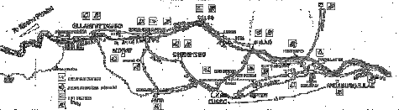
The archeological park is located of the city of Cusco it contain more than 200 archaelogical sites. Leading to Sagsayhuman there are two pared roads one starts in the old and tradition neighbourhood of San Cristoball and is about 1,5 kilometres long and the other road begins at
Arenida Collasuyo.

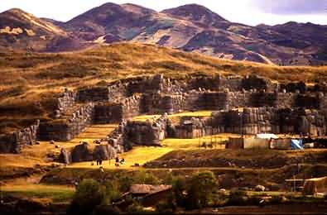

TRISEVGENY ALEXI-ARISTEA KOYTSOBITI B1-B2

