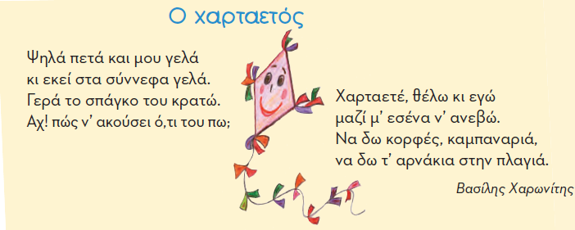

|  |  |  |
| --- | --- | --- |
|  | | |
|  | C:\Users\Geo\AppData\Local\Microsoft\Windows\INetCache\Content.Word\xartaetos 1.png |  |