MRS. SULTANA’S ALPHABET COOKIES
- Ingredients
¾ cup of butter
1 glass of sugar
2 eggs
¼ cup of orange juice
1 spoon of ammonia
1 vanilla
4,5 cups of flour
orange zest
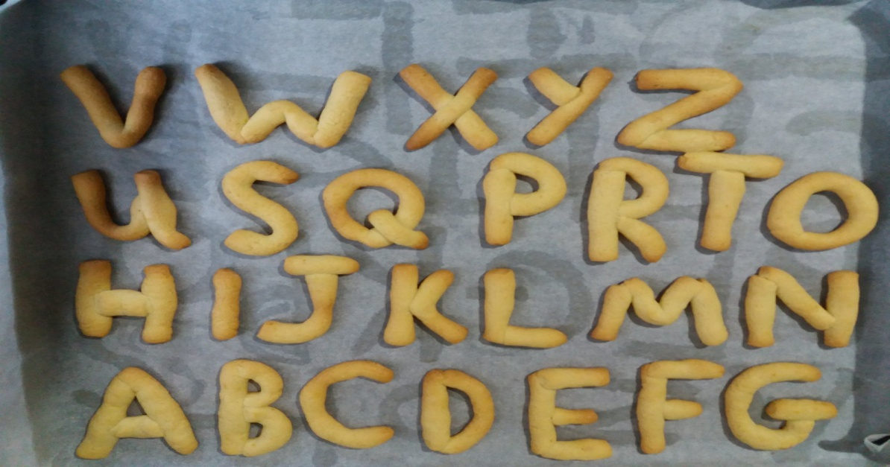

- Procedure
- Mix the butter with the sugar.
- Add the eggs and beat them.
- Mix ammonia with the orange juice and pour it in the batter.
- Add vanilla extract and the orange zest.
- Add one cup of flour at a time and mix the batter.
- Make the alphabet cookies.
- Bake them in the oven at 175 C for 20-25 minutes
- Enjoy!!!

