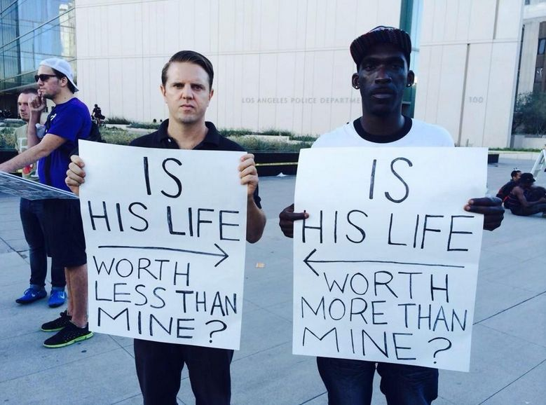

**Missouri's days of unrest expose the stark reality of a segregated society**

As the governor declares a state of emergency, the clashes that followed the death of Michael Brown highlight the divisions at the heart of America's cities.

The spectacle of American police acting like an occupying army in the St Louis suburb of Ferguson has shocked and baffled outsiders, but there was an explanation, of sorts, in a sleepy, tree-lined street just five minutes' walk from the mayhem.

Vickie Place is a row of single family homes built in the 1950s. They are modest but spacious, with gardens front and back, plenty of squirrels and a constant buzz from cicadas. The family of Michael Brown, [the unarmed 18-year-old African American gunned down by police last Saturday,](http://www.theguardian.com/world/2014/aug/11/st-louis-protesters-officer-teenager) occupies a cream-coloured house with a peeling door, a broken bell and a tattered chair on the porch.

The teargas and screams from West Florissant Avenue, where mainly white police used military might to cow black protesters, did not reach Vickie Place, just a few blocks away. But a simple fact about the street, and those around it, sheds light on the police mindset: one by one, carload by carload, year by year, decade by decade, in an inexorable, remorseless exodus, white faces, faces like theirs, have vanished. The legacy, for the white officers supposed to police it, appears to be a forbidding, alien, territory. A land of the other. It might as well be Falluja.

On Saturday the governor Jay Nixon declared a state of emergency and imposed a curfew between midnight and 5am saying the state would not allow a "handful of looters" to endanger the community and that there must be calm if justice is to be served.

"The police don't like coming here," said Don Williams, 52, who moved to Vickie Place with his family in 2001. "It was majority white then. Now, almost all black." The absence of street lighting made everything pitch dark after sunset, intimidating patrols, he said. "We have break-ins but the police barely investigate. They're not worth nothing." Opposite the Brown home lives one of the street's last white residents, Doris McCann, who has lived here for 55 of her 86 years. "It's a changed neighbourhood. Everyone that's white moved out," she lamented.

White flight is a familiar phenomenon in many countries but the use of armoured vehicles and sniper nests in the height of a [Missouri](http://www.theguardian.com/world/missouri) summer has exposed the extent and consequences of segregation in America's heartland.

The separation of races should in theory be a fading anachronism given that a black man occupies the White House and black artists suffuse mainstream culture. But half a century after the civil rights movement triumphed, the dream of an integrated multiracial society in this sprawl by the Mississippi is largely dead. As black families moved to nicer areas, exploiting newfound freedom, white neighbours fled. "It was gradual but they all packed up. You'll find them now in St Charles, Chesterfield, Wildwood, Alton," said McCann.

St Louis is far from the worst case. [A study last year](http://www.businessinsider.com/most-segregated-cities-in-america-2013-11?op=1), using different measures, ranked parts of Buffalo, New York, Cleveland, Detroit and Milwaukee even more segregated. The alienation cuts both ways. In Ferguson many black residents believe only the worst about police, black or white. Johnson, the highway patrol captain, adroitly defused a tense gathering of youths. He shook hands, listened, engaged, flattered. Johnson was black and grew up in the area but represented a hostile, external force. The youths drifted away, peaceful but not placated. "He may be ice, may be cool, but he's a cop," s

Adapted from [The Observer](http://observer.guardian.co.uk), Saturday 16 August 2014 18.01 BST

[Rory Carroll](http://www.theguardian.com/profile/rorycarroll) and [Jon Swaine](http://www.theguardian.com/profile/jon-swaine) in Ferguson