RELAXATION ΤΙΜΕ!!!
ACTIVITY A. Watch the “Gets you back to you” video and answer the quiz:
- What is being advertised?

- Everyday life and responsibilities are likened to
- A dream
- A breezy, calm journey
- A stormy sea
- While being at rough sea the protagonist feels
- Calm and relaxed
- Distressed and worried
- Angry and obsessive
- Finally, she “meets”
- Her sister
- Her friend
- Herself

- The slogan “gets you back to you” might mean that
- It helps find yourself again after a hard day
- It relaxes you
- It excites you
- What type of sequence is this?
- Drama
- Comedy
- Animation

- How would you characterize this spot? Is it successful in any way?
- What does it make you feel?
- Can you think of other TV ads that have stayed with you?
- Now watch “Go your own way” too.
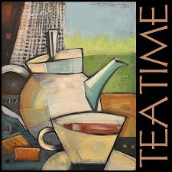
ACTIVITY B. Here are some historical facts about tea. Fill in the missing gaps with the words given.
17th century
Rich
Lower classes
Coffee houses
China
Relax
Traders
Mug
Milk
Lemon
Bridge (verb)
Originated

- Although the custom of drinking tea dates back to the 3rd millennium BC in…………….. (1), it was not until the mid-………………..(2) that the beverage first appeared in England.
- It was the Portuguese and Dutch …………………..(3) who first imported tea to Europe, with regular shipments by 1610.
- In the beginning when tea was exotic and expensive, it was mainly consumed by the fashionably…………….. (4).
- Tea gained popularity quickly in the……………………. (5), and by 1700 over 500 coffee houses sold it. This distressed the tavern owners, as tea cut their sales.
- By 1750 tea had become the favoured drink of Britain's ……………………… (6).
- Afternoon tea is said to have ………………………. (7) with one person; Anna, 7th Duchess of Bedford. In the early 1800's she launched the idea of having tea in the late afternoon to ……………… (8) the gap between luncheon and dinner.
- In Britain today, the drinking of tea is so varied that it is quite hard to generalise, but usually it is served with ……….. (9) and sometimes with……………(10).
- A cup or commonly a……………. (11) of tea is something drunk often. It offers a time of the day when people can ……………….. (12) and talk to each other. It has gained popularity among young people as well.
ACTIVITY C. The pictures on the right depict the correct order of the steps taken during tea time. Match them to the phrases on the left.

- Enough boiling water is swirled around the teapot to warm it and then poured out | 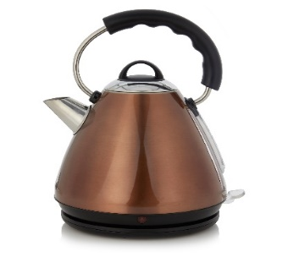
- The kettle, with fresh water, is brought to a boil. | 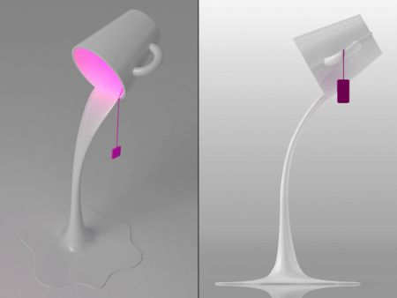
- White sugar or lemon is added according to individual taste. | 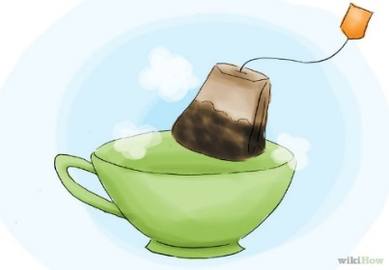
- The teabag is placed in the cup. | 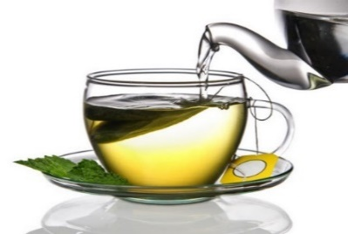
- Fresh boiling water is poured over the tea and allowed to brew for 2 to 5 minutes. | 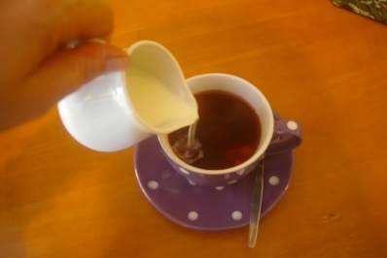
- Milk may be added to the tea cup. | 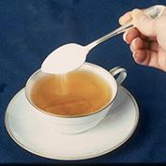

ACTIVITY D.
- Now watch a clip from the 2013 movie “The Great Gatsby” and answer.
Who is the host?
Who are the guests?
Who serves?
Do they use tea bags?
What can they add to their tea?
What does Daisy take in her tea?
What does Gatsby take in his tea?
What is the atmosphere / mood of the meeting?
- Then try to act out a dialogue between three people who have met to drink some tea and spend some time together.
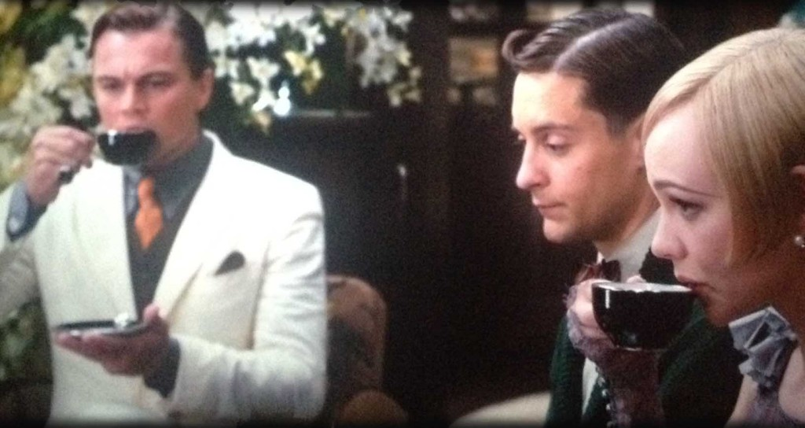

Next time we meet, it is TEA TIME!!!!!

