***Talking about depression***

1. **Fame demands a face but Sia managed what seems like an unprecedented feat for a female pop star: faceless fame. She says: “If anyone, besides famous people, knew what it was like to be a famous person, they would never want to be famous.”**

Sia Furler is a 38-year-old Australian woman whose name you probably know, whose songs you almost certainly recognize, but whose face you probably don’t. For years, she’s written huge songs for the most visible of pop stars – [Beyonce](http://www.theguardian.com/music/beyonce), [Rihanna](http://www.theguardian.com/music/rihanna), [Katy Perry](http://www.theguardian.com/music/katy-perry) and [Kylie Minogue](http://www.theguardian.com/music/kylieminogue) among them. Creating hits is her enormously lucrative day job and, according to a recent New York Times profile, she can toss them off in minutes. ([David Guetta’](http://www.theguardian.com/music/david-guetta)s “Titanium” – forty minutes; Rihanna’s “[Diamonds](http://www.youtube.com/watch?v=lWA2pjMjpBs)” – fourteen.)

Furler has suffered from depression. She has said that she also suffered from addiction to painkillers and alcohol and in June 2010, Furler's official website announced that all scheduled promotional events and shows had been cancelled due to her poor health. Today Sia is getting better but performing without showing her face, a choice that makes her feel safe and protected.

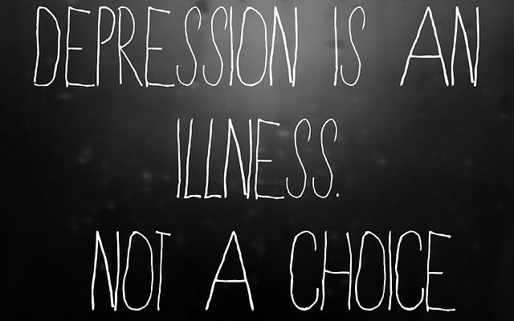

1. ***Depression in numbers (taken from the World Health Organization)***

|  |
| --- |
| Disorder treatments point receive worldwide affected lead |

* Depression is a common mental………….. Globally, more than 350 million people of all ages suffer from depression.
* Depression is the leading cause of disability……………………..
* More women are ……………………by depression than men.
* One in five people become depressed at some ……………….in their lives.
* At its worst, depression can ……………….to suicide.
* There are effective ………………..for depression.
* Fewer than half of those affected in the world (in some countries, fewer than 10%) …..........treatment.

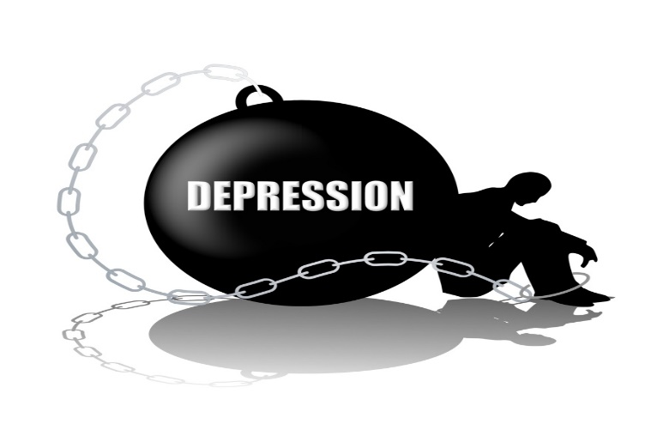

1. ***HELP***

There are things you can do to help yourself if you are experiencing depression or sadness. **Match the two halves and discuss. Which do you think is most helpful?**

* Talk to exercise.
* Get some fresh someone you trust
* Get some regular if it is small meals.
* Do things you enjoy whether it is air most days
* Try to eat regularly even to experience depression
* Write a diary about how you are feeling.
* Remember – you are not the only one skateboarding, hanging out with friends

1. **Now listen to a song Sia wrote about her time fighting depression and do the activities.**

***Sia - Breathe Me***

* + - 1. ***Fill in the verbs in the correct tenses.***

*Help, I ……………… (1) it again  
I ……………… (2) here many times before  
………… (3) myself again today  
And the worst part is there's no one else …………… (4)*

* + - 1. ***Write the refrain.***

|  |
| --- |
| *Be* |
|  |
|  |
|  |
|  |
|  |

*Ouch, I ……………… (5) myself again  
Lost myself and I am nowhere to …………… (6)  
Yeah, I think I …………… (7) break  
Lost myself again and I …………………….(8)*

