**MOMONDO SESSION**

**PRE-VIEWING ACTIVITIES**

1. What is shown in the first picture? Why is it important for us?
2. Which of the words in the second picture represent the helix in picture 1?

1. Defence Nuclear Agency
2. Deoxyribo Nucleic Acid
3. Dental Nucleic Acid



1. Check your understanding of how DNA works:
2. Every human being shares 99% of their DNA with every other human TRUE / FALSE
3. We have 98% of our DNA in common with a chimpanzee TRUE / FALSE
4. Humans have 40 chromosomes TRUE / FALSE
5. Changes in the DNA sequence are called mutations TRUE / FALSE
6. Every human being that existed up until around 6,000 or 10,000 years

ago had brown eyes. TRUE / FALSE

1. DNA tests cannot identify relationships between people. TRUE / FALSE
2. A parent and child share 50% of their genes. TRUE / FALSE
3. Having blue eyes means that you received at least one “blue-eyes” gene

from one of your parents. TRUE / FALSE

1. Dark characteristics (such as dark skin or brown/black eyes) are stronger

and dominate over light characteristics (such as blue eyes, fair skin) TRUE / FALSE

1. Humans are related only if they are part of the same family TRUE / FALSE



**WHILE-VIEWING ACTIVITIES 1st VIDEO**

1. **You are going to watch a short video called “The DNA journey”. What do you think it will be about?**

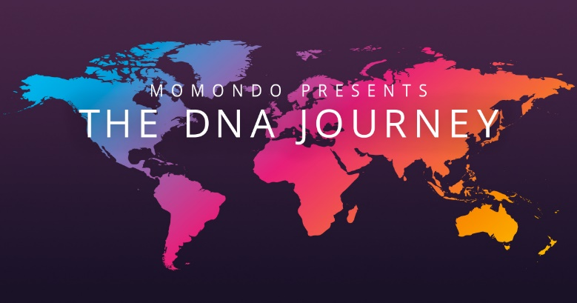

1. **Now match the two halves while watching the first part (1:11 minutes)**
2. I am proud a. Turkish people.
3. I am really patriotic b. proud blacks.
4. I am 100% c. of the Germans.
5. We are just d. than a lot of people.
6. I think we are probably the best e. Icelandic, definitely.
7. I am not a fan f. country in the world.
8. There’s a side of me that hates g. about Bangladesh
9. I am strong and more important h. to be English
10. **Find at least one phrase from the above that can be characterised as “racist”.**
11. **Fill in the gaps while watching (until 1:45 minutes):**

Do you know how DNA works? So, you get ______ from mum and ______ from dad. So, it’s 50% from each of them and they get 50% from their _________ and back and back and back…..And all those little bits of ancestor, they ________ down to make you……You!

**POST VIEWING ACTIVITIES**

1. **Now watch again and in the end try to choose the correct answer a, b or c.**
2. Most people have stereotypical ideas about other nationalities.
3. TRUE b. FALSE c. NOT STATED
4. The test is supposed to show the participants
5. their relatives b. their ethnological origins c. their personality
6. The expert asks the participants to __________ (in) a tube.
7. breathe b. touch c. spit

4. Most of the participants believe that the test will show

a. their true ancestry

b. they belong to one specific ethnological group

c. they are a mixture of races

5. The man from ____________ says he is a bit nervous.

a. Africa b. Cuba c. England

6. The Kurdish woman finds it surprising that she descends from

a. Asia b. Eastern Europe c. Turkey

7. Why is that a shock to her?

a. She dislikes people coming from that area

b. She thinks it is a mistake

c. She dislikes that country’s strategy toward her people

8. The British man is also __________ German

a. 30%

b. 100%

c. 5%

9. Why do you think the man from Cuba is surprised with his results?

a. Because they include a part of the world he hates

b. Because they include a part of the world where people are white, while he’s coloured

c. Because they include a part of the world he had always wanted to visit

10. What was the final surprise?

a. Two complete strangers are from the same area

b. Two complete strangers are distant relatives

c. Two complete strangers are siblings

11. In the end, the acceptance of their multicultural origins is shown by two phrases:

a. I am Jay ____________________________________________

b. I am a real __________________________________________

12. Would you like to take this DNA test?

13. What would it offer you? What would possibly surprise you?

**2nd VIDEO**

1. **Now watch the Amnesty International video and answer the questions:**
2. **This is a social experiment where people are asked to talk for 5 minutes.**

**TRUE FALSE NOT STATED**

1. **The eye contact is expected to bring them together.**

**TRUE FALSE NOT STATED**

1. **Use the words to fill the gaps:**

|  |
| --- |
| **Experience live introduce talk gestures play alone** |

* **A man tries to describe his age using hand ………………………….**
* **A woman asks a man if he is new in Berlin and whether he’s ………………… there or with his family.**
* **He responds he is alone and has been ………………… in Berlin for 8 months.**
* **A young woman and a young man ………………………. themselves and start …………………….**
* **Two kids start ……………………… in the studio.**
* **A man claims he could tell by looking in the other person’s eyes, how much ………………. she has had.**

1. **Name the countries the people came from.**

|  |
| --- |
|  |

1. **Do you know what Amnesty International is?**
2. **Why do you think they have created this video?**
3. **Describe the feelings of the immigrants.**
4. **Describe the feelings of the native inhabitants.**

**Now listen to a beautiful song by U2 and fill in the gaps.**

***ORDINARY LOVE _-__ U2***

1. **Fill in the missing verbs**

The sea ________ to ___________ the golden shore  
The sunlight ______________ your skin  
All the beauty that's _____________ before wants to __________ us again

I ______________ you any more, it's you I'm _______________ for  
the sea ___________ rocks together but time _____________ us polished stones

We can't _____ any further if  
We can't ______ ordinary love  
And we cannot ________ any higher,  
If we can't ______ with ordinary love

1. **Correct the words in bold which have been put in the wrong place.**

Birds **rest** high in the summer **breeze** and **fly** on the **sky**.  
The same **care** will take **wind** of you and I.  
We'll build our house in the trees.

1. **Fill in the next 2 lines of the song**

|  |
| --- |
|  |
|  |

For years I would believe that the world couldn't wash it away!  
We can't _____________ any further if  
We can't _____________ ordinary love  
And we cannot _____________ any higher,  
If we can't ______________ with ordinary love

1. **What is the final question???** _____________________________________________
2. **Name all the places / material used to write on.**

|  |  |  |  |
| --- | --- | --- | --- |
|  |  |  |  |
|  |  |  |  |
|  |  |  |  |

1. **Whose figure is painted on a wall? What do you know about him/her?**
2. Martin Luther king **2**. Nelson Mandela **3**. Rosa Parks
3. **Which two words are written on each of the wrists?**
4. **What do you think “ordinary love” might be?**



**HOMEWORK:**

**Choose a song with strong social message and bring it to class. Prepare a presentation of the song/lyrics in English.**