Space oddity
- LISTENING GAP FILL
David Bowie is (1) _________ __________. He was one of the most original, innovative and influential rock stars in music history. He was also an actor, fashion icon, record producer, (2) artist and______ ___________. He was born in London on the 8th of January, 1947 and died at the age of 69 on the 10th of January, 2016. His real name was David Robert Jones but he changed (3) it because_______ ________ another David Jones singing in the 1960s.
David Bowie first became (4) ___________________ his 1969 hit "Space Oddity". This song was released just ten days before the first Moon landing. In 1972, Bowie became a (5) ________________of the glam rock movement. He wowed and shocked people with his make-up, dresses and flamboyant costumes. His Ziggy Stardust persona was the first of many different characters Bowie (6) _______ ________ ______ time he changed musical direction.
Throughout the 1970s and 1980s, Bowie continued to break new (7) _________ ________ his music. In 1975, he experimented with soul music and had a number one hit in the USA with the song 'Fame'. He also helped to (8) ___________________ the electronic and new romantic movements in the mid-1970s. In the early-80s, he was one of the first artists (9) ____ _______ ________ promote his songs.
Throughout the 1990s and 2000s, Bowie continued to experiment with (10) ___________ ________, including industrial and jungle. His fans thought he had given up making music (11) ________ ______________ break starting in 2003. He surprised the world by suddenly announcing a new album, 'The Next Day' in 2013. He released his final album days before his death. Many (12) _________ _______ __________ was Bowie's goodbye to his fans.

2. SYNONYM MATCH
1. | legend | a. | amazed
2 | original | b. | develop
3. | released | c. | creative
4. | wowed | d. | publicize
5. | persona | e. | genres
6. | experimented | f. | icon
7. | pioneer | g. | character
8. | promote | h. | followers
9. | styles | i. | made available
10. | fans | j. | explored

3.Choose one of the word given
alienation classic difficulty zone space abuse
The song has become an all-time ____________. It talks about an astronaut who decides to step out of his capsule and into ________ but unfortunately, disaster strikes and he loses contact with Earth thus drifting into space forever.
While some claim that the song is a reference to drug ___________, there is evidence that supports that Bowie wrote it to represent the sense of ____________ he was feeling at the time. Major Tom’s inability to contact the control room symbolizes the artist’s ___________ to connect with others around him. His decision “I'm stepping through the door” could stand for any person’s decision to leave their comfort ___________ and venture into the unknown while doing something they like or trying new things.
4. Fill in the gaps while listening to the song

Space oddity by David Bowie
Ground Control to Major Tom  Ground Control to Major Tom  Take your protein pills and put your ...................(1) on  Ground Control to Major Tom  Commencing ........................ (2), engines on  Check .......................(3) and may God's love be with you  Ten, nine, eight, seven, six, five  Four, three, two, one, liftoff  This is ground control to Major Tom  You've really made the grade  And the .................(4) want to know whose shirts you wear  Now it's time to leave the .................... (5), if you dare |  | 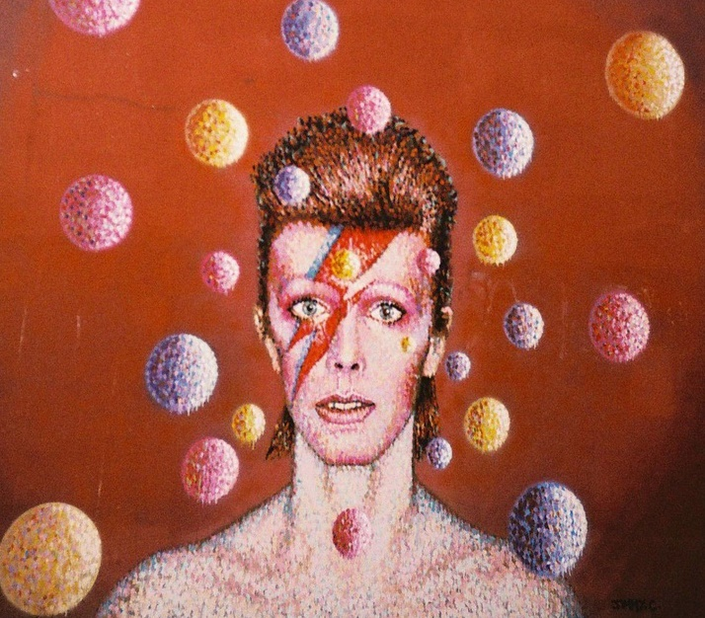

This is Major Tom to Ground Control  I'm stepping ...............................................(6)  And I'm floating in a most ..........................(7) way  And the stars look very different today  For here am I, sitting in a tin can  ...................................... (8) the world  Planet Earth is blue  And there's nothing I can do  Though I'm past .............................. (9) miles  I'm feeling very ........................... (10)  And I think my spaceship knows which way to go  Tell me wife I love her very much, she knows  Ground Control to Major Tom  Your circuit's ....................(11), there's something wrong  Can you hear me, Major Tom? | 5. Watch a part of the documentary “Finding fame” (51’ – 58’) and answer:  - What was the inspiration for the song? _______________________________________________  - Why was 1969 an important year for space exploration? _________________________________  - What is the meaning of “oddity”? ___________________________________________________  - According to Bowie himself the song expressed his feeling of _____________________________  - What characteristics made this song special according to the producer? Choose:  Dramatic intro // notes used // new instrument // science fiction quality // vocals // the melotron // topic  - This was Bowie’s first hit: TRUE / FALSE

KEY

 | legend | a. | icon
2 | original | b. | creative
3. | released | c. | made available
4. | wowed | d. | amazed
5. | persona | e. | character
6. | experimented | f. | explored
7. | pioneer | g. | develop
8. | promote | h. | publicize
9. | styles | i. | genres
10. | fans | j. | followers

LISTENING IS ON:
https://www.famouspeoplelessons.com/d/david-bowie.html
David Bowie is a music legend. He was one of the most original, innovative and influential rock stars in music history. He was also an actor, fashion icon, record producer, artist and art critic. He was born in London on the 8th of January, 1947 and died at the age of 69 on the 10th of January, 2016. His real name was David Robert Jones but he changed it because there was another David Jones singing in the 1960s.
David Bowie first became famous following his 1969 hit "Space Oddity". This song was released just ten days before the first Moon landing. In 1972, Bowie became a leader of the glam rock movement. He wowed and shocked people with his make-up, dresses and flamboyant costumes. His Ziggy Stardust persona was the first of many different characters Bowie would use every time he changed musical direction.
Throughout the 1970s and 1980s, Bowie continued to break new ground with his music. In 1975, he experimented with soul music and had a number one hit in the USA with the song 'Fame'. He also helped to pioneer the electronic and new romantic movements in the mid-1970s. In the early-80s, he was one of the first artists to use videos to promote his songs.
Throughout the 1990s and 2000s, Bowie continued to experiment with musical styles, including industrial and jungle. His fans thought he had given up making music after a ten-year break starting in 2003. He surprised the world by suddenly announcing a new album, 'The Next Day' in 2013. He released his final album days before his death. Many believe the album was Bowie's goodbye to his fans.

